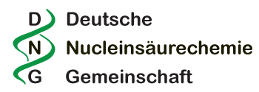
Breakthrough research in nucleic acid chemistry

A. Presenter, B. Coauthor, C. Othercoauthor, D. Contactauthor*

University of Hometown, Department of Chemistry
e-mail: contactauthor@uni-hometown.de

The abstract should contain the central questions or statement of the problem your research addresses, what’s already known about this question, or what previous research has done or shown.[1]
This is followed by the rationale and the goals of your research. Why is it important to address these questions, or why is that topic worth examining? Are you filling a gap in previous research and/or to take a fresh look at existing ideas or data? You may also mention your research approach and/or analytical methods.[2]
Then follows the summary of your main results and arguments, and a statement that highlights the significance or implications of your findings.

The abstract should be intelligible on its own. Figures and references may be included.
Please limit the overall length of the abstract to this one A4 page only.

Figure 1. A brief figure caption.

References
[1] A. Presenter, B. Coauthor, D. Contactauthor, Title of a fancy nucleic chemistry paper, Angew. Chem. Int. Ed. 2022, 61, 1234-1237.
[2] A. Presenter, C. Othercoauthor, D. Contactauthor, Exciting and unexpected results from synthesis of modified DNA. J. Am. Chem. Soc. 2023, 145, 234-238.

